**Project Documentation:**

**Week 3 – Task 1:**

***Quiz Application***

**Submitted By: Zara Khan**

**Submitted To: A&D Tech**

**Dated: 19th July, 2024**

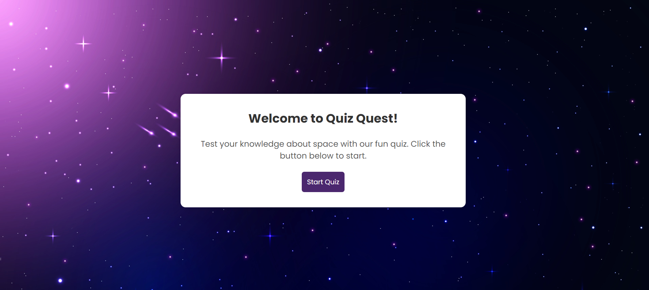

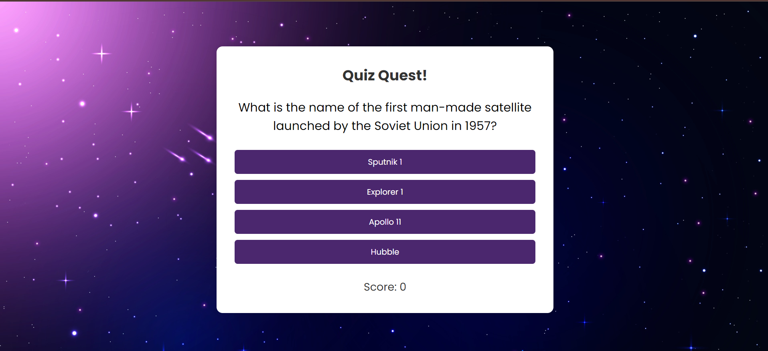

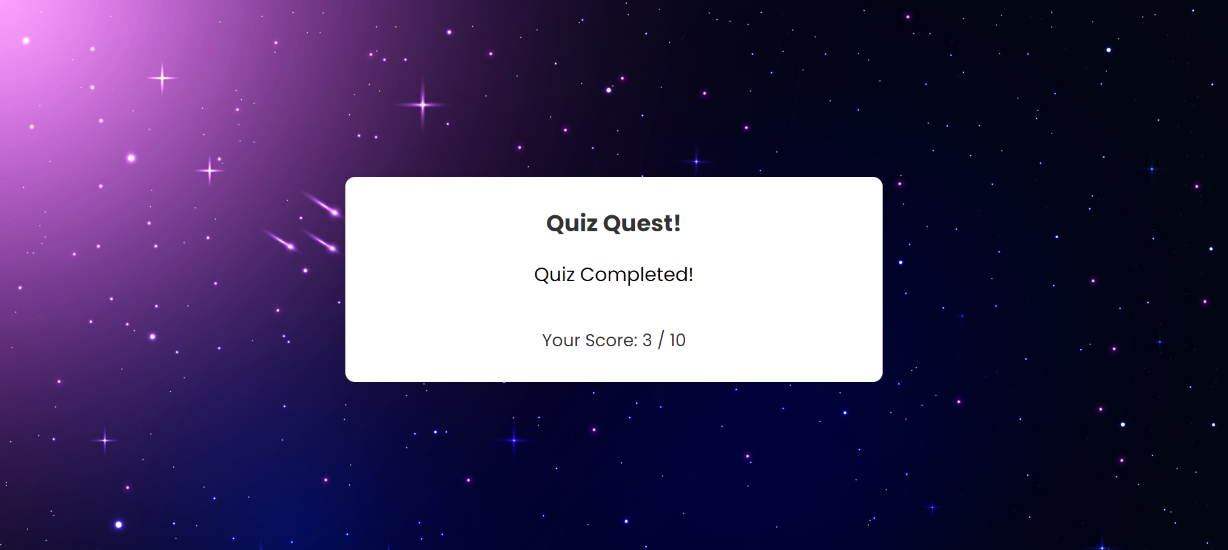

**CASE: Wrong Answer**

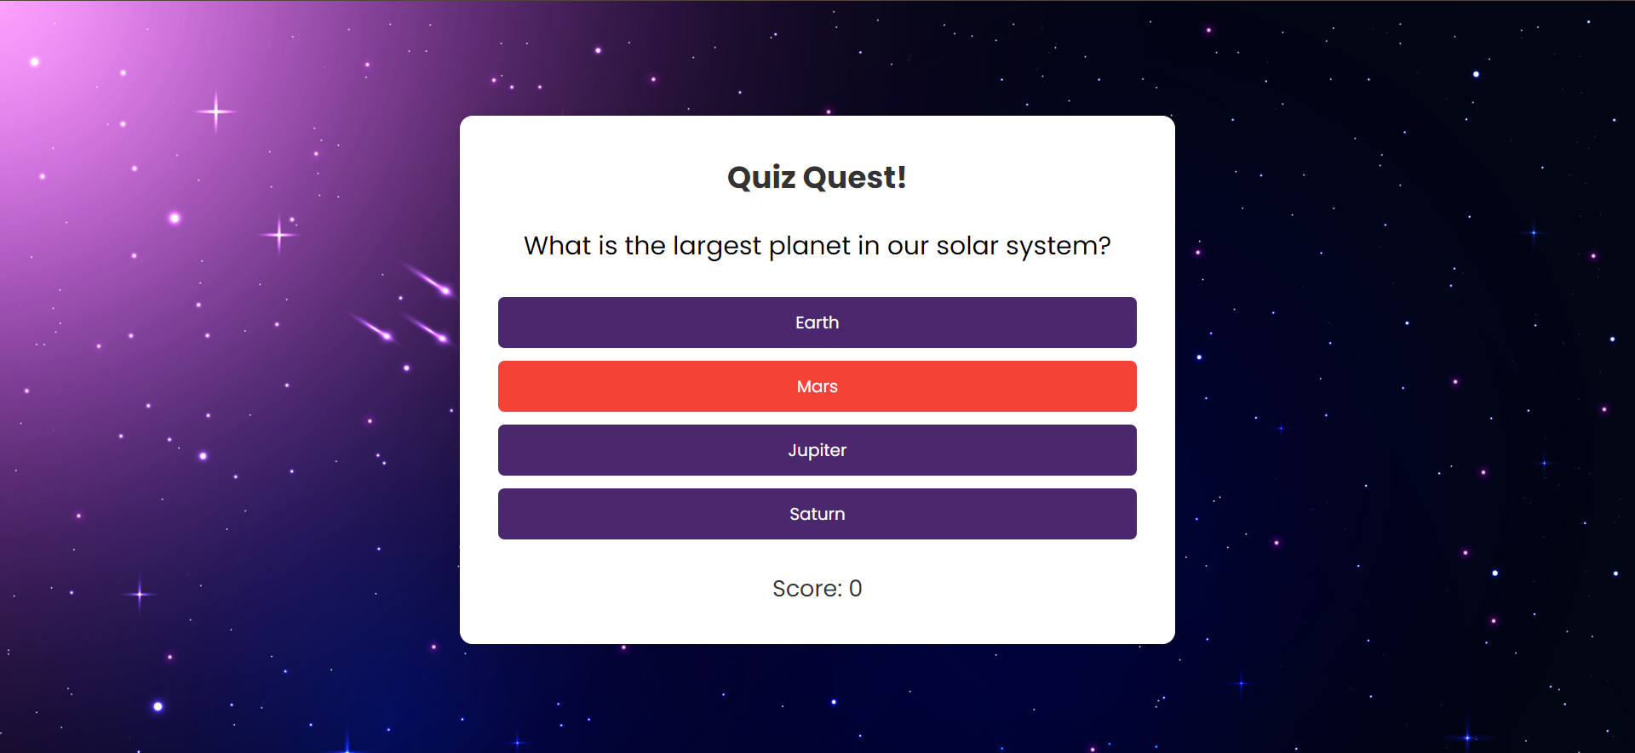

**CASE: Right Answer**

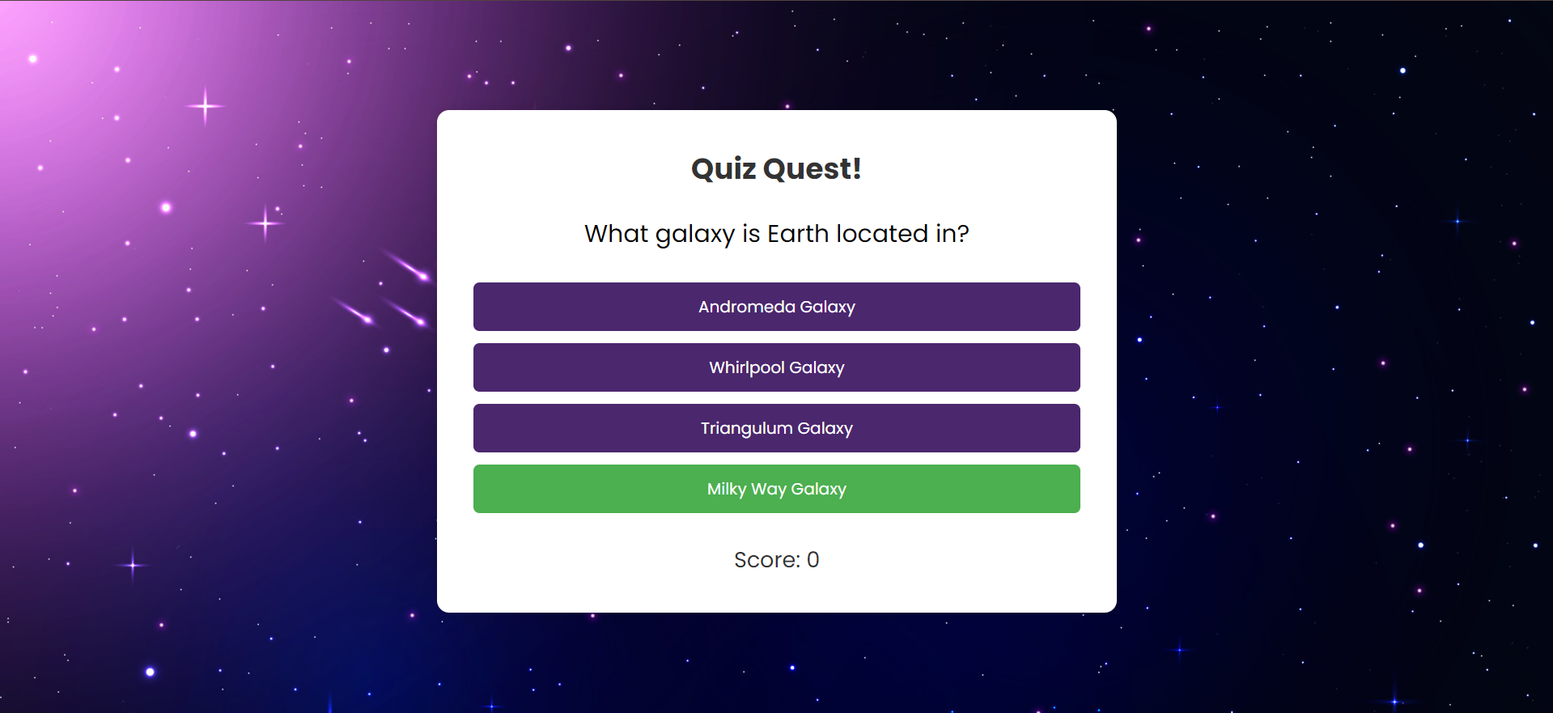

***Problem Statement***

Develop a single-page quiz application that presents multiple-choice questions and provides immediate feedback to users. This project will strengthen your skills in JavaScript, especially in managing events, manipulating the DOM, and maintaining the application's state.

***Solution Overview***

I developed the Quiz App with a structured layout featuring a welcome screen, quiz screen, and results screen. The welcome screen includes a brief introduction and a "Start Quiz" button. The quiz screen dynamically displays questions and options, providing instant feedback on user selections. The results screen shows the final score and offers a "Retry Quiz" option. The app is spaced-theme with centered content, modern styling, and smooth user interactions managed by JavaScript.

***Challenges and Resolutions***

**Challenge: Displaying Feedback Colors**

* **Initial Issue**: Ensuring the correct answer button turned green and the wrong answer button turned red when selected was challenging.
* **Approach**: I tried various CSS techniques and JavaScript logic to dynamically update button styles based on user input.
* **Resolution**: Successfully implemented feedback colors by using JavaScript to add and remove CSS classes for correct and wrong answers.

***Instructions***

**Setting Up the Project**

1. **Download the Project Files:**
   * Clone the repository from GitHub.
   * Alternatively, download the project zip file and extract it to your local machine.
2. **Open in Visual Studio Code (VS Code):**
   * Launch VS Code.
   * Open the entire project folder using File > Open Folder.

**Running the Project**

1. **Navigate to the Main Page:**
   * In the VS Code sidebar, locate and open QuizApp.html.
2. **Solving the Quiz:**
   * Click on “Start Quiz” and answer 10 questions. In the end, you can see your total score and an option to retry the quiz if you want.
3. **Testing Responsiveness:**
   * Use VS Code's built-in preview or open the website in different browsers and devices to ensure responsiveness.